Sponsored by
COMO BOWLING & RECREATION CLUB INC.

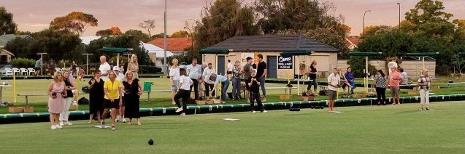

JACK ATTACK
4 week Community Barefoot Bowls Competition

Commencing Friday 11th November 2022
arrive 6.00pm for a 6.30pm Start
$80.00 per team
ENTRY FORM

Team Name:______________________________________

Skipper:_________________________________________

Second:_________________________________________

Lead:__________________________________________

Substitute:______________________________________

Team Contact Person: Name: ______________________

Phone:______________________

Competition dates: 11th November
18th November
Flat soled shoes or barefoot and bowls provided
25th November
2nd December

Entries Close: Monday 8th November 2022
Entries can be emailed to: comobowlsclub@hotmail.com or
Phone: Maree 0437503884

Payments can be made by EFT to:
Westpac
BSB: 036308 ***New Bank Account***
ACC: 413308
Refer: Team Name-JackAttack

In Jack Attack you can create a team of three players plus 1 substitute and challenge other teams to 4 weeks of bowls in a relaxing and enjoyable environment.

Our competition dates are:-
Friday 11th November
Friday 18th November
Friday 25th November
Friday 2nd December

Games are approximately 60-75 minutes in duration. Each team requires a minimum of 3 players, however, you may have up to 6 players in a team, and you may substitute your players during the game numerous times. If you are unable to play one week, and your team is registered, you may nominate any other player to play on your behalf.

It is $80.00 per team to enter the 4 week competition. All equipment required is provided by the club and this includes bowls. If you do have your own bowls, please feel free to bring them along.

You may wear what you like as long as you are comfortable,. Your team might decide on a team uniform. Flat soled shoes are required for the protection of our greens – if you don’t have suitable footwear you may play barefoot.

We are child friendly so your little ones are very welcome to come along. Those over 13 years of age may participate.

If you have never played bowls before there is no need to worry ! There will be plenty of very helpful club members and a coach to help you along the way.
For more information or to enter a side before Wed 7th October 2020, please contact the club on 93673923 or M: 0437503884 or comobowlsclub@hotmail.com
We hope to see you on the Green !!!

